

PAYMENT PROCESSING IN RUSSIA

ABOUT US
Onpay is a payment aggregation service, which enables merchants worldwide to accept payments in Russia and CIS. We have dozens of payment systems, including most popular in Russian Internet (Yandex.Money, WebMoney, QIWI, e.t.c). We also accept payments via banks, payment terminals, credit cards, SMS. The comission of the service is 1%, comissions of payment systems are 2-3,5% on average, the comission can be paid by the buyer or the merchant. (all the payment systems with comisslions are listed here: http://onpay.ru/usloviya-i-tarify/tarify) We have 18.000 registered services (as of end 2013th). We provide payment aggregation service since 2006, we are one of the oldest aggregators in the Russia/CIS e-commerce market.

DISCLAIMER
The English version of our web site is currently under construction. Yet, English speakers are welcome and we are ready to provide maximum support via feedback form and other channels. The vital information about our service is located on the page you are currently reading. You may encounter numerous pages in Russian, which are currently being translated to Russian. We suggest you use http://translate.google.com/ for fast translation, and our feedback form for any clarification you may need (just press «Ask question» on any page of the merchant panel, add screenshots if necessary). We apologize in advance for any inconvenience this may cause. Google Translate is also built in into onpay.ru website, just select your language in upper right corner.

REGISTRATION
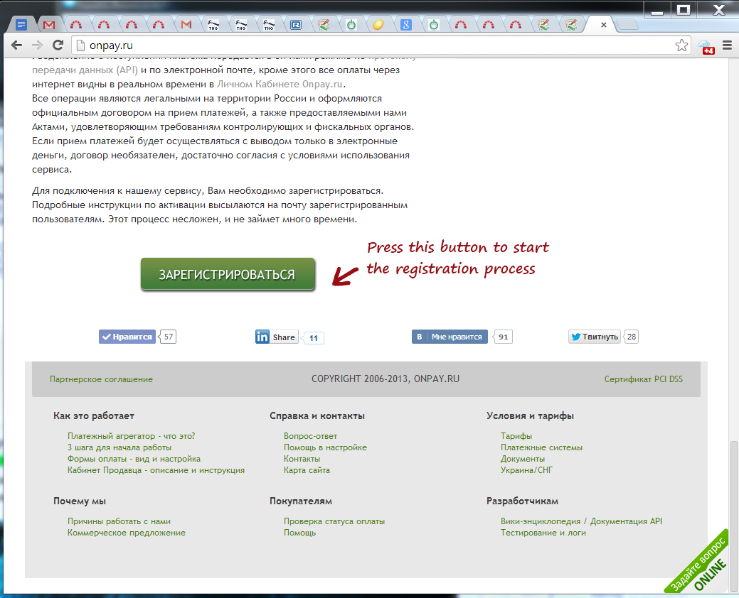
The FIRST STEP you need to make to start working with us is Registration. This is a simple procedure, by filling 2-3 dozens of fields you create your personal account in our system, which enables you to login to merchant panel and use our services. Registration is carried out on this webpage: https://secure.onpay.ru/signup?ln=en. Or, you can just press the Registration button on our home page:
After registration you may login to yor merchant panel and start working.

MERCHANT PANEL
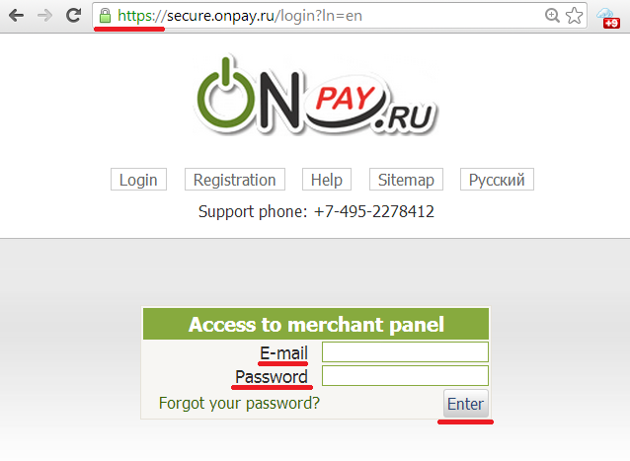
Merchant panel is Web-based interface to manage your account at Onpay.ru. In Merchant panel you can change the settings of accepting payments and view payments and payment orders, manage your funds. You can also exchange e-currencies, or withdraw money from the system to your electronic purse, credit card or bank account. You can login to merchant panel from https://secure.onpay.ru/login?ln=en using your email and password (make sure, that this is a secure HTTPS connection):

ACTIVATION
Activation is a simple process, all instructions will be sent to you by email after registration . To activate your account, use your e-mail and password to login to Merchant panel: https://secure.onpay.ru/login. Then press «enable real payments» and press ОК after you fill in all the fields.
Before you press OK make sure that you have:
- Clear description of the goods and/or services that you offer
- Terms of delivery of goods or services
- Contact information so you can be contacted quickly
- Link to the page from where you clients will be transferred to Payment form
- If your site is closed to visitors - send login+password to enable us evaluate your site.
IMPORTANT: you will not be able to receive payments if you are not activated. Make sure, that your business field is not blacklisted here: https://secure.onpay.ru/signup?ln=en.

CONTENT REQUIREMENTS
Before you press «enable real payments», please make sure, that your web site has:
1. At least one product or service with the actual price and the ability to arrange purchase (button, shopping cart). Web sites with sample and demo products NOT allowed to activation. Clear description of the goods and / or services that you sell is also a requirement.
2 . Description of the terms and conditions of delivery of goods or services. Shipping costs should also be available. IMPORTANT! When selling services rather than goods, one must have an offer (terms of service).
3 . Contact details so that you can be contacted quickly . These data must be the same in the Merchant panel of the seller («Contacts for buyers» are shown in Payment Form) and your web site.
4 . Description of the service or the shop. The site should be at least one page that answers the questions of who you are and what you offer. Create a Temporary Account for moderation, if the site or part of the services are closed from public access .
NOTE: Sites are activated only in your domain. Sites on the third-level domain only activated if the primary domain belongs to you. Web sites on the free domain and hosting are NOT activated.

SIGNING THE CONTRACT
Signing a contract with foreign companies. The contract is concluded by signing the Declaration on accession to the Treaty for foreign companies (Application Form is in the Metchant panel, in the «Administration» section, subsection «Company»).
Please fill in all the applicable fields, save, then print 2 copies of the application with your hand. Verify that your banking details are correct. Attach to the application copies of certificates of incorporation (reg #) and Tax Registration (VAT, if you have one ), a copy of the document confirming the authority of the signatory your company stamp and signature of the head.
Signed copies please mail to the address : 109052 , Moscow, ul. Nizhny Novgorod , 86-A« , apt. 38 «MAGNUM» LLC.
Received application will be signed by our side and your copy will be sent your return address you specified on the envelope ( specify address, zip code , which is guaranteed to be delivered by mail).
Please note, that, depending on the region you live in, it may take time to deliver, so we provided an option to scan and upload signed document to start working immediately.

